ASSIGNMENT

WORDPRESS ACCOUNT : <https://wordpress.com/setup/site-setup/patternAssembler?siteSlug=businessman25.wordpress.com&siteId=224978231&screen=main&screen_parameter=header>

CANVA ACCOUNT : <https://www.canva.com/praba>

FACEBOOK BUSINESS : <https://m.facebook.com/story.php?story_fbid=pfbid02zHxXKRQv95GjZiioCiBeuGGW5doP87hDTgSEhp3keBwddsLAWdXeaizVDBHe7P4Nl&id=61552209767554&mibextid=Nif5oz>

CREATE A POSTER USING CANVA

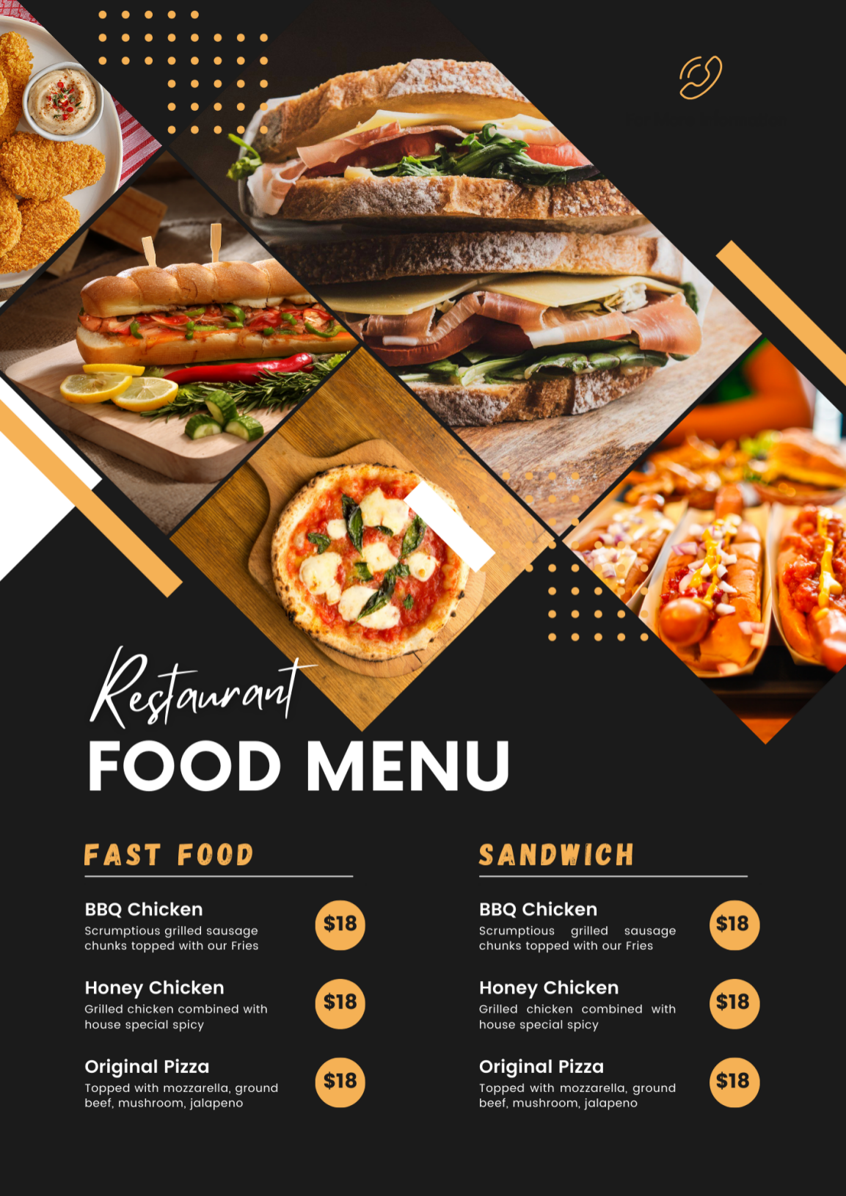

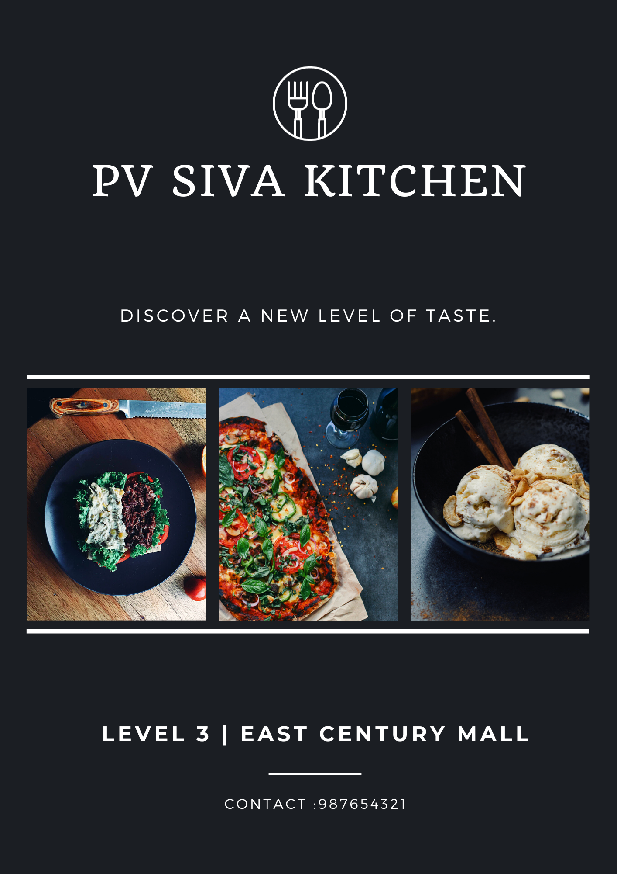

SOICIAL MEDIA LINKS

<https://m.facebook.com/story.php?story_fbid=pfbid02zHxXKRQv95GjZiioCiBeuGGW5doP87hDTgSEhp3keBwddsLAWdXeaizVDBHe7P4Nl&id=61552209767554&mibextid=Nif5oz>

<https://m.facebook.com/story.php?story_fbid=pfbid0gN4Tiqj5dyq812z4NJMS5JshQ133TaF53bFWoReGVr98GFEygxMdX22tL8prd33wl&id=61552209767554&mibextid=Nif5oz>

<https://m.facebook.com/story.php?story_fbid=1046583886373260&substory_index=1046583886373260&id=61552209767554&mibextid=Nif5oz>

<https://businessman25.wordpress.com/2023/10/22/food-court/>

NEWS LETTER :

